Extract from BS 8419-1:2005 and BS8419-2:2005 “Interoperability between metadata systems used for learning, education and training”

To obtain a copy of either Part of BS 8419, contact orders@bsi-global.com, quoting reference BS 8419:2005, or order online through http://bsonline.techindex.co.uk/. Source – http://www.schmoller.net/documents/bs8419.doc. For explanation see http://www.schmoller.net/mailings/20050328.shtml.

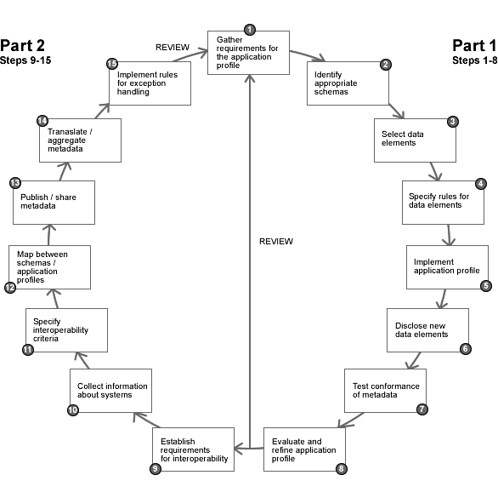

Figure 1 – Tasks involved in developing an application profile and establishing interoperability

This British Standard code of practice is intended for practitioners who develop and implement e-learning, e-learning content, and e-learning systems, including (but not limited to):
- instructional designers, developers, publishers, and vendors of e-learning materials and qualifications;
- developers and vendors of software systems which are used in the design and delivery of e-learning and assessment;
- those with responsibility for procuring e-learning materials or software systems for e-learning and assessment.

Scope from Part 1 - Code of practice for the development of application profiles
This British Standard gives recommendations for achieving interoperability between systems in learning, education and training.
The standard provides guidance:
- on the development and reuse of application profiles;
- for the use of application profiles where interoperability is a requirement.
Where application profiles are developed solely for local use, then this standard as a whole is not applicable, although individual recommendations could still prove useful.
The standard is applicable across all sectors and levels of learning, education, and training. Whilst the requirements of different communities can lead to the development of different application profiles, the processes underlying the development will be common.
The standard provides guidance on the reuse of BS ISO 15836 Dublin Core Metadata Element Set (DCMES) developed by the Dublin Core Metadata Initiative (DCMI), and the IEEE 1484.12.1-2002 standard for Learning Object Metadata (LOM) developed by the Institute of Electrical and Electronics Engineers (IEEE) Learning Object Metadata Working Group.
The standard makes recommendations about encoding mechanisms (e.g. XML DTD, XML schema, RDF) for application profile bindings but does not mandate the use of any particular encoding mechanism.
The standard does not provide mechanisms for evaluating or comparing the educational value of learning resources.
The standard is intended to optimise, rather than completely remove, human interaction in the transfer of information between systems.

Scope from Part 2 - Code of practice for the development of interoperability between application profiles

This British Standard gives recommendations for achieving interoperability between systems in learning, education and training.
The standard is applicable across all sectors and levels of learning, education, and training.
The standard describes an overall approach for maximizing interoperability, which is applicable across different types of interoperability requirement.
The standard describes general mechanisms for mapping between different vocabularies but does not provide recommendations or restrictions relating to the choice of vocabulary within any individual situation.
The standard makes recommendations about the advantages in different contexts of different encoding mechanisms (e.g. XML DTD, XML schema, RDF) for metadata to enhance interoperability but does not mandate the use of any particular encoding mechanism.
The standard does not provide mechanisms for evaluating or comparing the educational value of learning resources.
The standard is intended to optimise, rather than completely remove, human interaction in the transfer of information between systems.

To obtain a copy of either Part of BS 8419, contact orders@bsi-global.com, quoting reference BS 8419:2005, or order online through http://bsonline.techindex.co.uk/. Source – http://www.schmoller.net/documents/bs8419.doc. For explanation see http://www.schmoller.net/mailings/20050328.shtml.

